04.02
Maintenance Agreements
Process Design & AMOS Configuration Document
Purpose
This Process Design document is provided to Key-Users to record their key decisions regarding the AMOS Process design and the required AMOS configuration.
It is updated throughout the Project Definition Phase and used as the baseline for the Final Acceptance prior to Go-Live
Revision
Author, Name | Date | Notes
Dimitri Dupont | 01.06.2024 | First Version

Table of Contents
1. Process Overview & Objectives 3
2. Regulatory References 3
3. Definitions & Glossary 3
4. Process Tasks 3
5. Process Dependencies 4
6. Process Flow 5
7. Process Design Questions 7
8. Data Source Mapping 11
9. Other Software Used 11
10. AMOS Configuration 12
a. Process specific configuration programmes 12
b. Basic Data 12
c. Parameters 13
d. Workflows 15
e. Scheduled Tasks 15
f. API’s & Interfaces 16
11. UAT Guidance 17
12. Annex – Additional Info 17

Process Overview & Objectives
Process General Description:
This process describes the creation, the assignment and the management of approvals and related documents for any address created in the system. Documents such as Aircraft certificate of release to service, Component certificate of release to service and validation of 3rd parts maintenance for aircraft and components.
Main Process Objective (Outputs & Outcomes):
With this process, the user can define the approvals per address, either internal or external. Multiple approvals can be assigned per addresses. Assigning an authority to an aircraft will prevent a CAMO to create a Workpackage for a non-adequately approved Maintenance Provider for this specific registration.
Additionally, the mandatory text for release documents can be pre-filled and automatically printed when releasing a workorder, or emitting a component release form.

Regulatory References
- EU No 1321/2014 Article 3
- EASA 145.A.20 Terms of Approval and scope of work.
- EASA 145.A.50 Certification of Maintenance
- EASA 145.A.205 Contracting & Subcontracting

Definitions & Glossary
Key-Words | Explanation
Approval Type | Type of approval to be used. Note that there is 2 different types of approval for P-145 organisation in AMOS, airframe and shop.
-/-

Process Tasks
Business Process Task / Actions / Activities:
- Create new Aviation Authority
The creation of an Aviation Authority should be done in conjunction of the definition of the approval type and release texts.
- Assign Approval to Organisation
Once the approval has been created, it has to be assigned to the respective organisations. These organisations can be external provider or internal shops.

Process Dependencies
INPUT | CONCURRENT | OUTPUT
04.01 – Company organisation  09.02 – Supplier Management | -/- | - 01.01 – Aircraft definition  - 03.01 – Planning  - 08.05 – Release to Service  - 09.03 – Ordering  - 09.04 – repair &Exchange  - 11.01 – Capability list  - 11.06 – Component Release

Process Flow

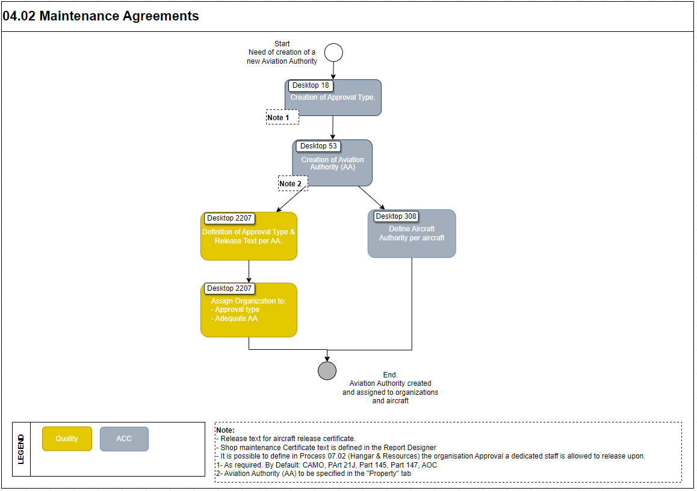

Process Design Questions
# | Question | Answer
1 | Which department manages the approval within your own company?
2 | Which department manages the supplier’s approval?
3 | How do you plan to records work performed by a 1rd party on your workorders?
-/-

Data Source Mapping
Data Sources | Description | Volume / Manual / Automatic / Static / Dynamic
-/- | -/- | -/-

Other Software Used
Other Software | Used by: | Description
-/- | -/-

AMOS Configuration

Process specific configuration programmes
AMOS APN | Notes
-/- | -/-

Basic Data
Basic Data Table | Notes
Approval Type | Various type of approval. By default, most common aviation related approvals are set.
Approval report Definition | Reports available in Report Designer defined with proper description.
Address Property Type | Properties definition and creation.
Address Type | Type of addresses definition and creation

Parameters
Parameter Code | Parameter Name | Notes
1803 | Approval number should be added to the approval number book | The standard configuration is recommend to be used.

Workflows
Workflow Number | Workflow Name | Workflow Setup Notes
-/-

Scheduled Tasks
Scheduled Task Reference | Frequency | Notes
-/- | -/-

API’s & Interfaces
Reference | Direction | Trigger | Frequency
-/-

UAT Guidance
Test case number | Test case description | Required data | Required resources
1 | Create a new Aviation Authority |  | ACC
2 | Create an approval type and release text |  | Quality
3 | Assign an approval type and the Aviation Authority to a Maintenance Provider |  | Quality
-/- | -/-

Annex – Additional Info
-/-

